**How to Update Generate Dashboard**

The dashboard is created by using data from four tables. Two are from Generate and two are geocode files. No changes were made directly to the Generate files – so pulling them should allow for easy updates. Your Geocode files should match both column/variable names and type (text, numeric, etc.) as the files used here.

The files are joined like this:

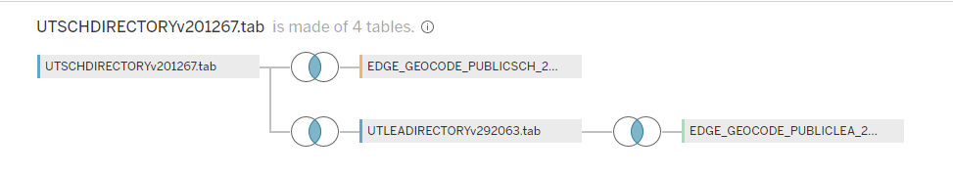

The main source is the School Directory from Generate. Inner joined to it are the School Geocode files, the LEA Generate file, and the LEA geocode file. They are joined by clicking Edit Join Calculation and putting TRIM([LEA Identifier (NCES)])+TRIM([School Identifier (NCES)]) on the School Directory and the School ID (NCES) in the geocode file.

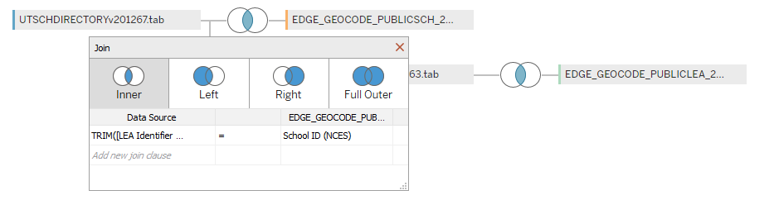

The LEA Generate file is inner joined by:

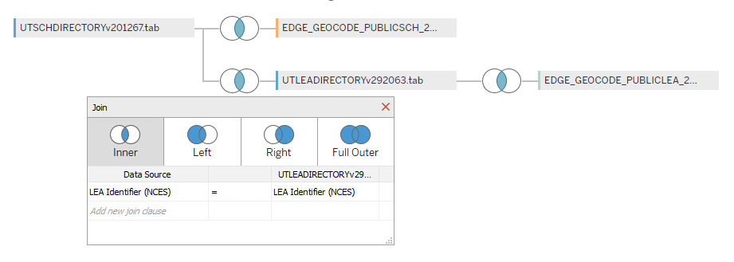

The LEA geocode file is joined to the LEA Generate file by:

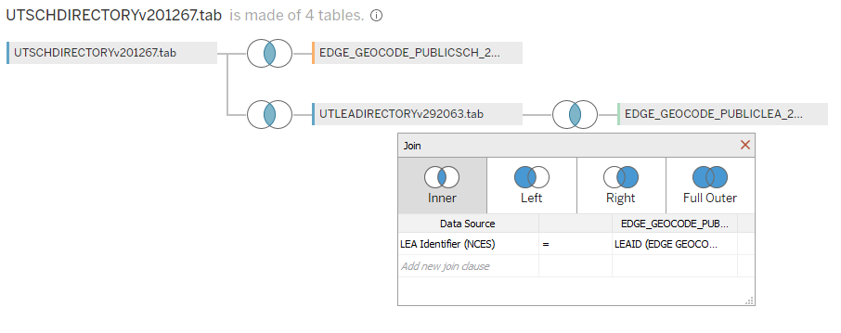

To edit the path to where your files are located, right click the file you want to update and click *edit connection*:

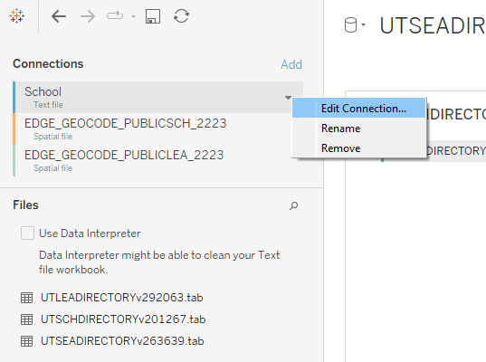

Choose the file that corresponds to the one you are updating. Please note, update a file with the same type of file (.xlsx to .xlsx, .tab to .tab, etc.).

Finally, you should refresh the extract. There are two ways and typically both are done to guarantee the file as refreshed. The first is click refresh:

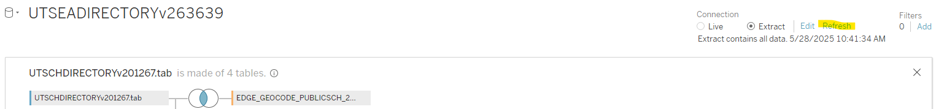

The second is refresh the extract through the data tab:

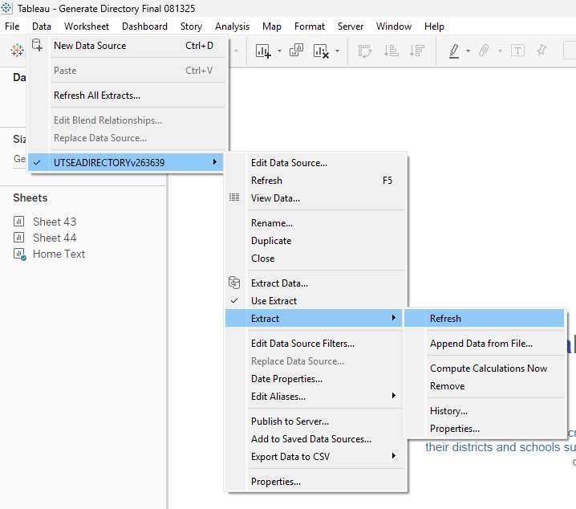

If your charts break or do not update correctly, check each dimension and measure in your data pane on a sheet and see why. It could be it read in a numeric when it should be ABC or vice versa. Stuff like that.

**How to Edit Pages**

Each dashboard is color coded. To edit sheets on a dashboard, right-click and ‘Unhide’ as the sheets are currently hidden to prevent confusion.

If you decide to add or delete sheets, note that there are Dashboard Actions that help each page run, and while they may not break your additions, are considered more advanced techniques and should be edited with caution.

Editing Titles, Labels, Tooltips, Charts within a Sheet, etc. should be fine.